Ex:No: 14

Date:

# HIGH LEVEL PROGRAMMING EXTENSIONS (PROCEDURES)

## PROCEDURES:

A procedure is a subprogram that performs a specific action.

## Creating a procedure

We use the CREATE PROCEDURE statement to create a new stored procedure. We specify the name of stored procedure after the CREATE PROCEDURE statement. The DELIMITER command is used to change the

standard delimiter of MySQLcommands (i.e. ;). As the statements within the routines (functions, stored procedures or triggers) end with a semi-colon (;), to treat them as a compound statement we use DELIMITER.

Calling stored procedures(Executing a procedure)

In order to call a stored procedure, you use the following SQL command:

CALL stored_procedure_name();

## Program 1:

Create a simple procedure to get all the records from the table ‘student_info’ which have the following data: mysql> select * from student_info;

+ + +- + +

| id | Name| Address | Subject |

+ + +- + +

| 100 | Aarav | Delhi | Computers |

| 101 | YashPal | Amritsar | History |

| 105 | Gaurav | Jaipur | Literature |

| 110 | Rahul | Chandigarh | History |

+ + +- + +

##### Program 2:

Create a stored procedure GetCustomerLevel() that accepts two parameters customer number and customer level.

First, it gets the credit limit from the customers table.

Then, based on the credit limit, it determines the customer level: PLATINUM , GOLD , an SILVER.

The parameter p_customerlevel stores the level of the customer and is used by the calling program.

The following flowchart demonstrates the logic of determining customer level.

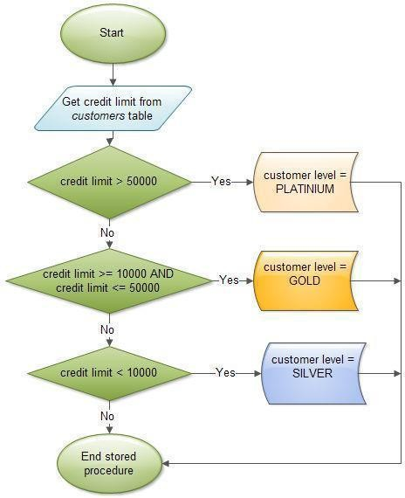

The table ‘customers’ should have the following attributes: customers(cno , cname, creditlimit)

